Classroom Training Lifecycle — Stages 1–4
Stage 1 — Training Needs Assessment (TNA)  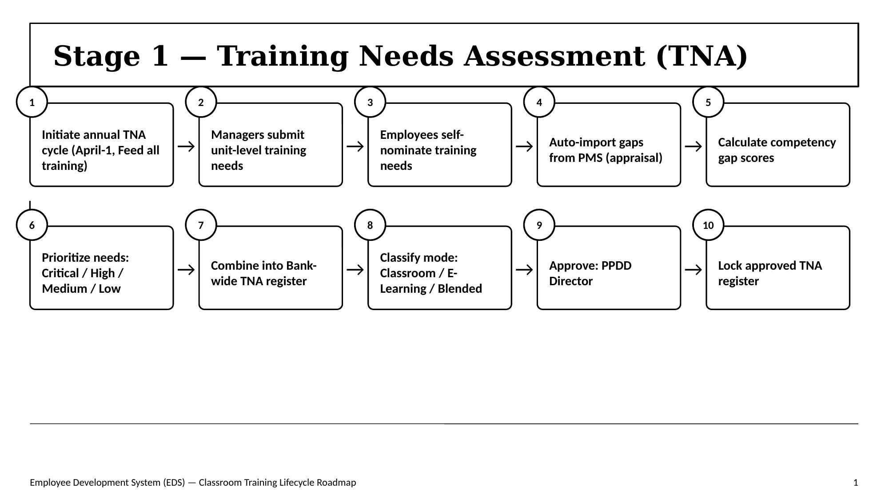 | Stage 2 — Annual L&D Plan & Calendar  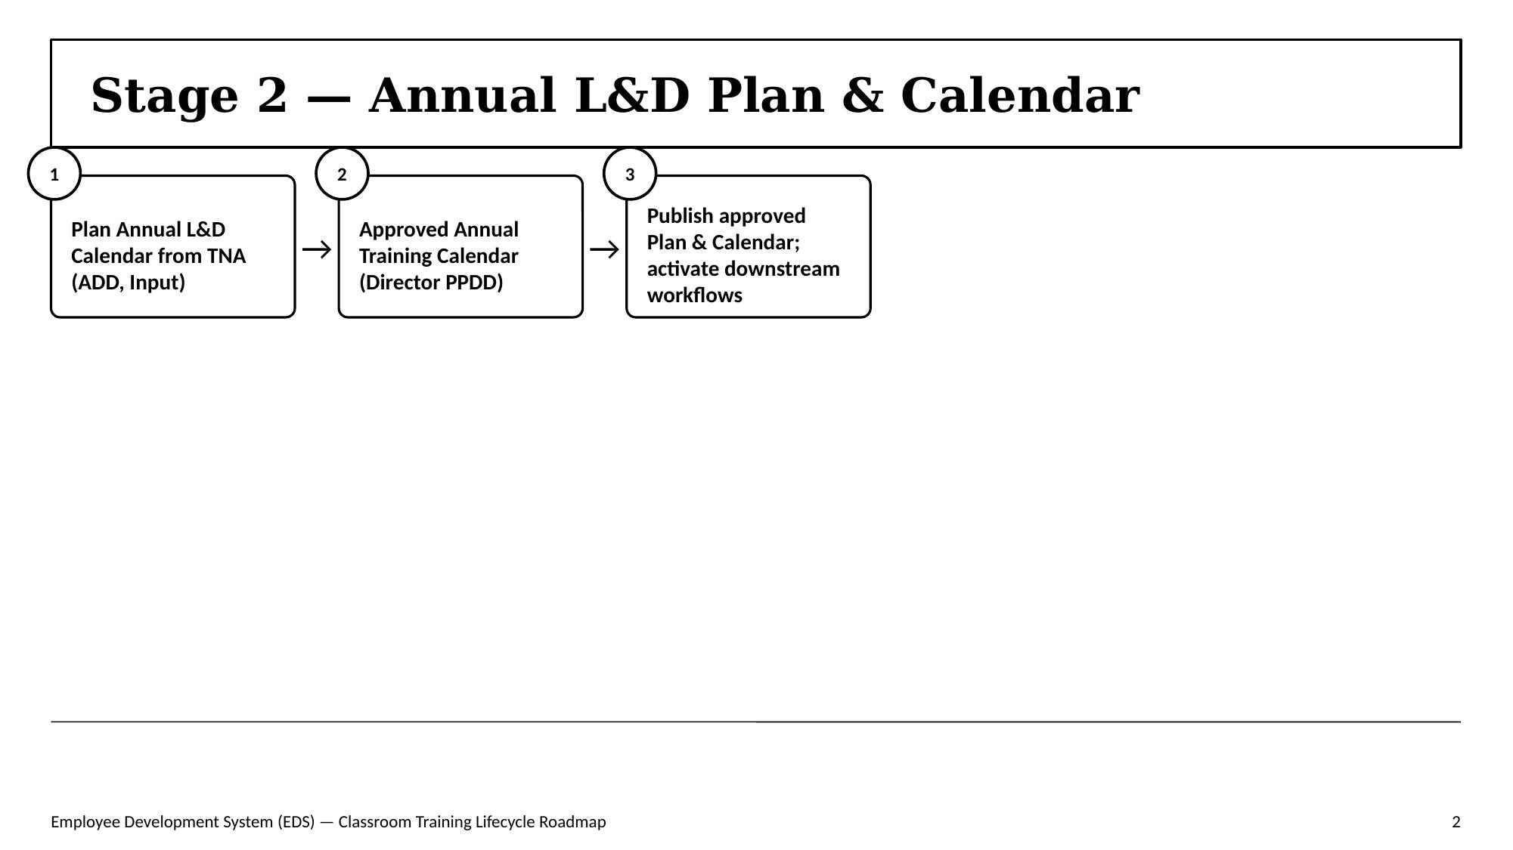
Stage 3 — Training Design  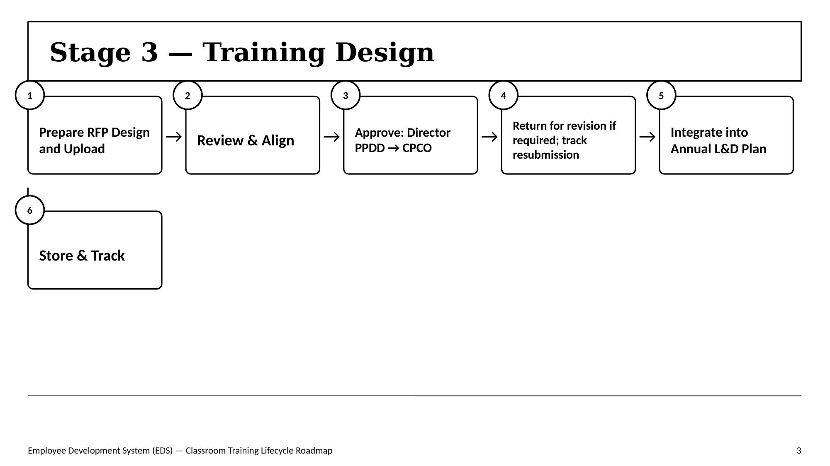 | Stage 4 — Budget & Cost Approval  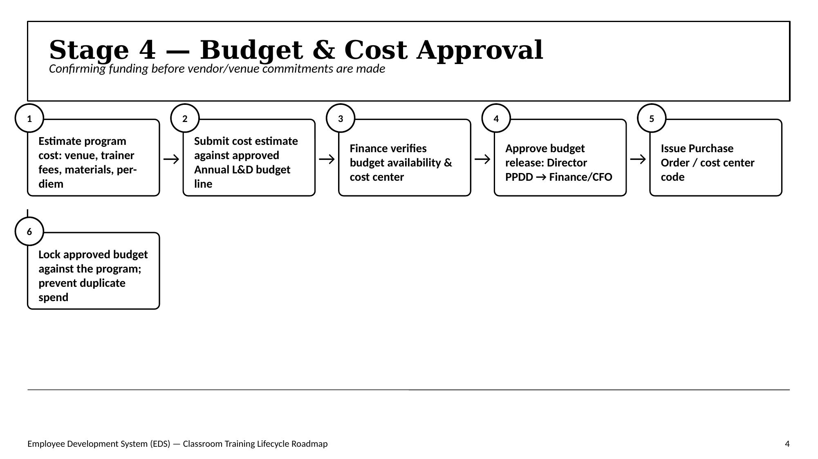

Classroom Training Lifecycle — Stages 5–8
Stage 5 — Vendor, Venue & Hotel Sourcing  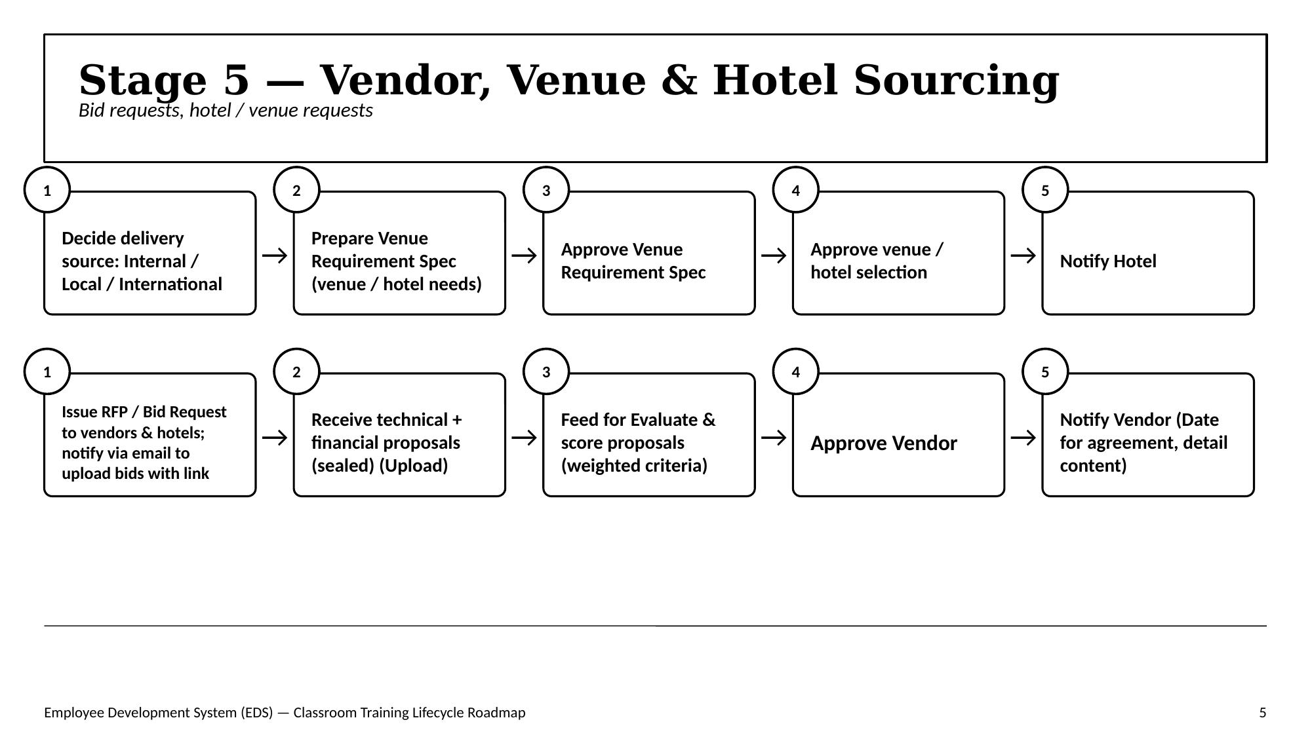 | Stage 6 — Scheduling & Arrangements  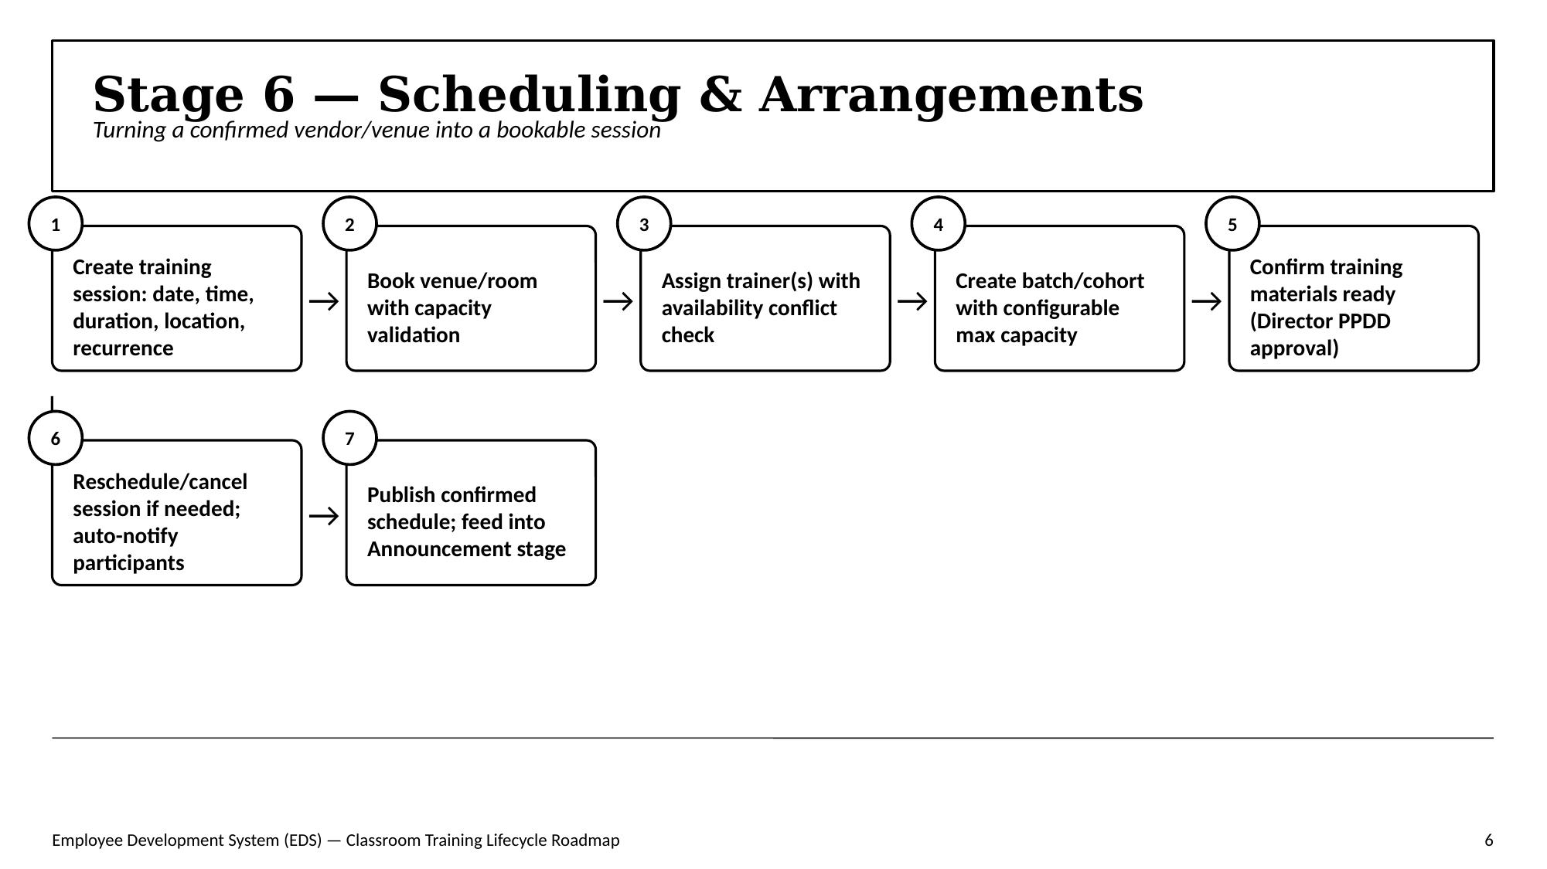
Stage 7 — Nomination, Approval & Enrollment  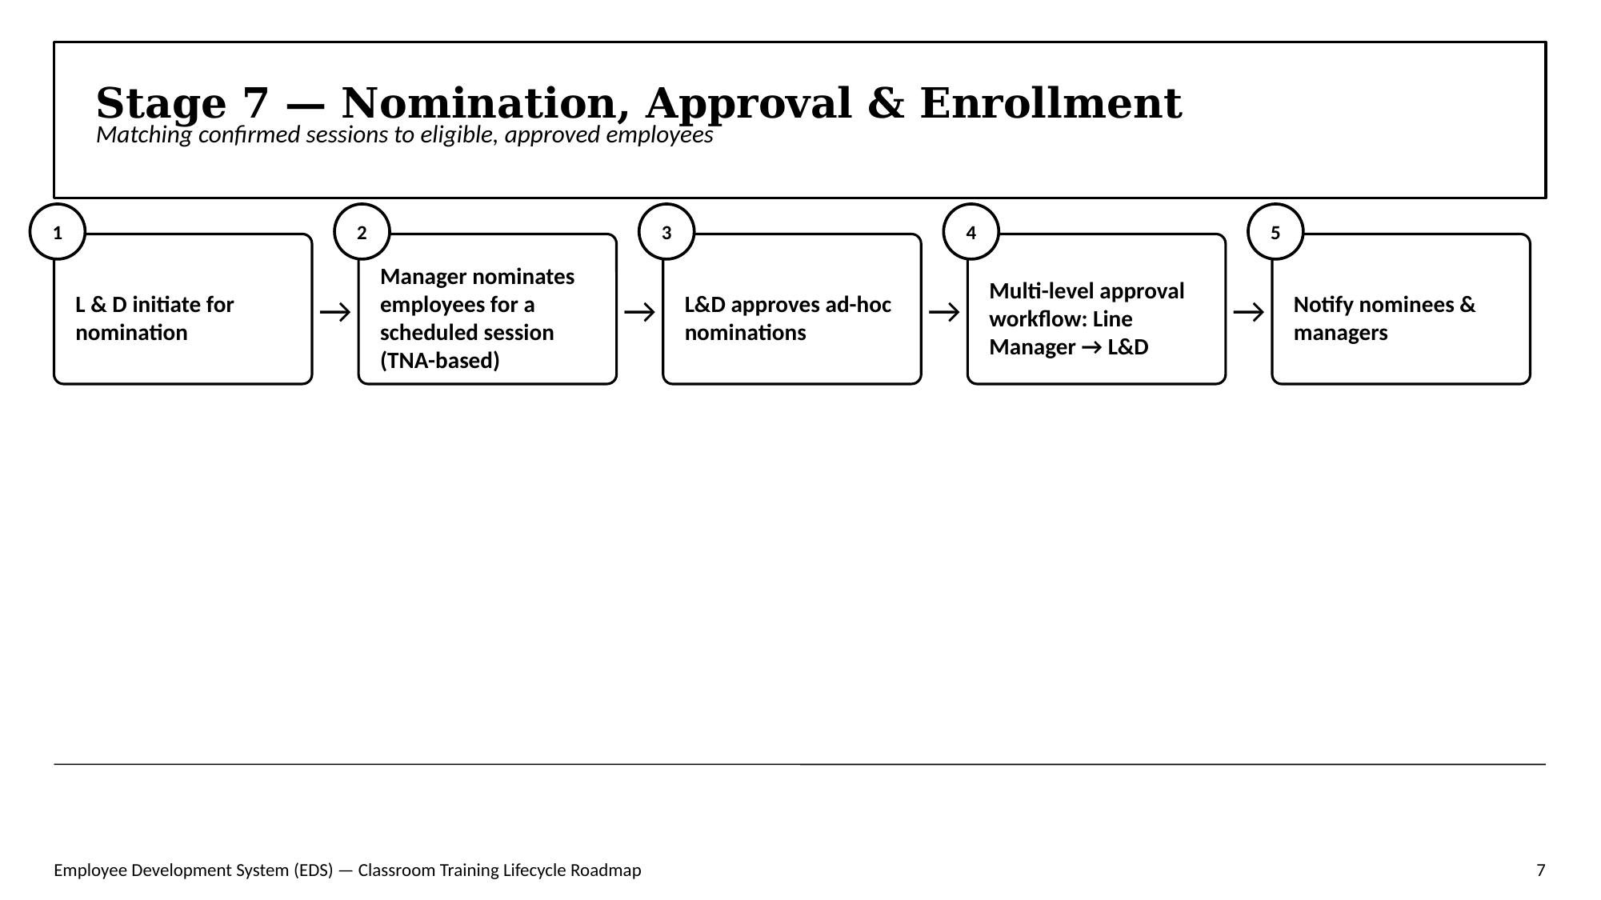 | Stage 8 — Announcement  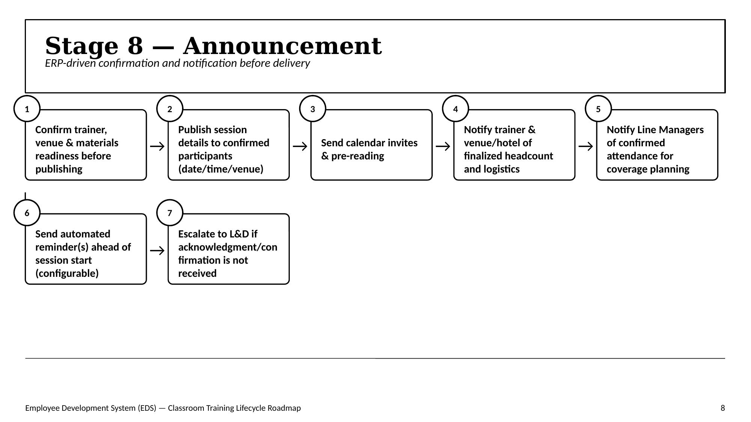

Classroom Training Lifecycle — Stages 9–12
Stage 9 — Training Delivery  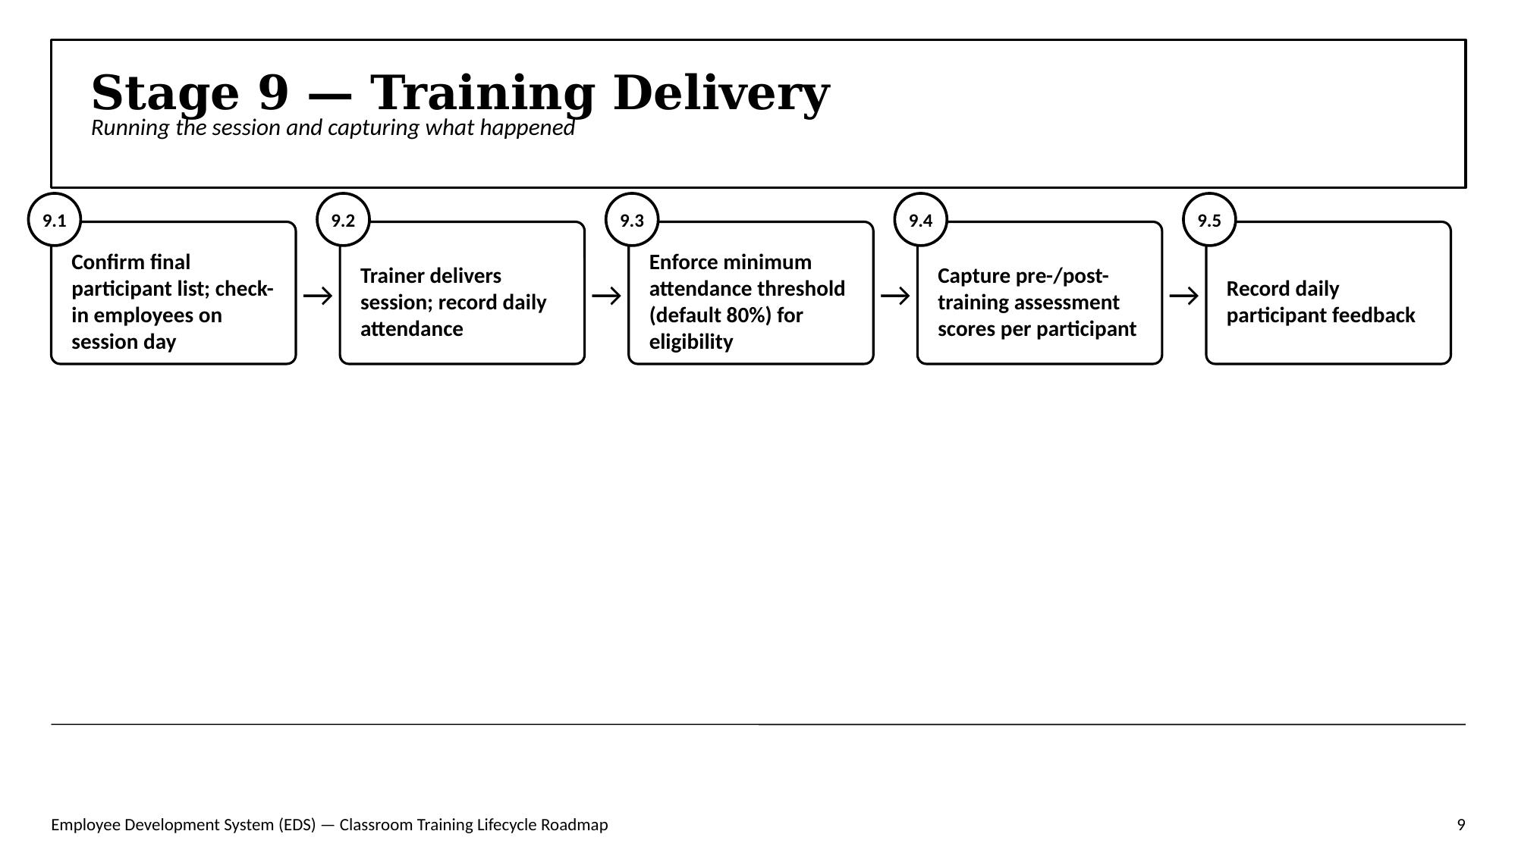 | Stage 10 — Evaluation & Assessment  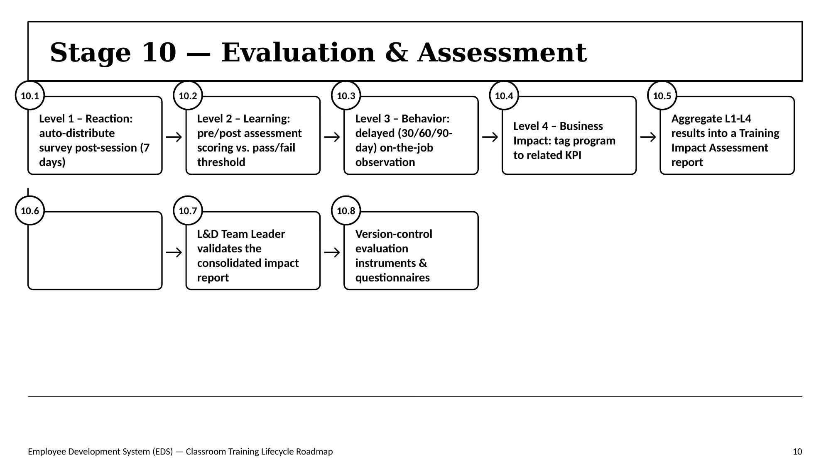
Stage 11 — Completion & Certification  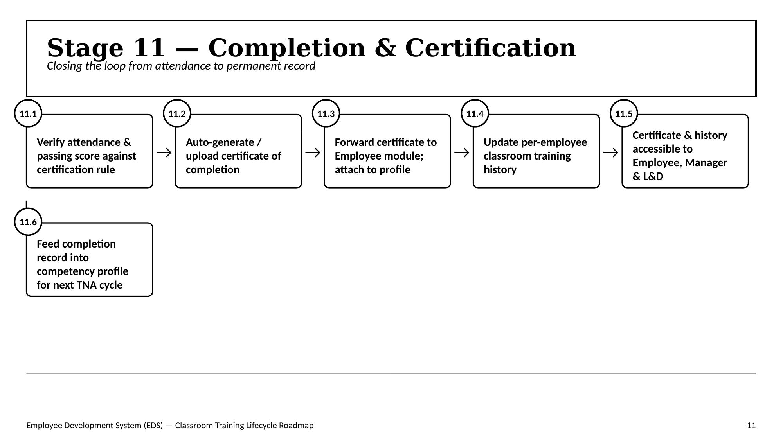 | Stage 12 — Financial Closure & Vendor Review  